London Bandits Hockey Association

Minutes | Date November 10,2020 | time 7:00 pm | online zoom

Meeting called by | Jack Boyce, President
Type of meeting | Regular Meeting
Secretary | LUISA GOULD, SECRETARY

Welcome | Jack Boyce, Chair welcomed everyone and called the meeting to order at 7:03 pm

ATTENDANCE | Lynsey Lamont, Pam McNichol, Dawn Devoy, Calvin Gould, Pat Robbins, Gayle Moore, Graham Babbage, Gary Chenier, Craig Loyst, Lisa McIntyre, Michelle Drown, Vicky Bossenberry, Kevin Caulfield, Nancy Putzer, Sara Hunter, Tina Barnes, Mike Branco, Don Drown, Sara Gilmore, Suzanne Whitmore, Kirsten Norton
ACCEPTANCE OF MINUTES | Motion to approve the minutes from Octobers’ board meeting (Gary Chenier, Graham Babbage) approve with 20 /22 votes in favour  Errors / Omissions- none
President | - Jack asked us to have a minute of silence out of respect for all our veteran’s for Remembrance Day.  - Reminder that our meetings on Zoom is confidential so you shouldn’t be near family members that are not part of the board.  - Lots of meetings lately, over covid, and I have asked Luisa to set it up and she never argues, and she just gets it done. Thanks, Luisa, for all the work behind the scenes that you do.  - Had a walk through with coaches outside, and inside, coaches asked a lot of great questions.  - Complaints through the city for Covid will let Tina talk about that later  - Tina’s working on getting some answers to some questions that have come up.  - Coaches are doing an awesome job based with the covid regulations etc and all the rules  - Kevin in IP is also doing a tremendous job with his group and all is flowing great.  - We had a President’s meeting last night and discussed the Registration for the second half of the season.  - Jack was thinking we open registration to the current group and then open up to the general public. Create a waiting list and if we get 10 more kids then add a team.  - Question will numbers change for the kids on the ice for the second half? No, it won’t change. We expected it to change in November and as you can see, we have lots of schools getting hit right now which will trickle into our associations.  - Will we change the aspect of combining Minor and major groups? No we will keep them the same.  - We will be having internal games for 4 weeks, then taking a break for a couple of weeks then have one dance partner such as west and play them for another 4 weeks.  - We will be playing 4/4 model  - Sara had a lot of questions regarding how this looks for registration, Jack said Luisa will organize a registration meeting to hash out those details and get that operating the best we can. There will be some slight issues but we will get them worked out.  - Ordering practice jersey’s and the kids will keep them.  - December 1st we will open the registration. Start day won’t be till January 4th.  - Novice – we normally play ½ hockey, 2 games at the same time, moving the nets close to the doors, coach behind the net, city doesn’t want us using the boards right now.  - Graham asked about pairing up with West to create a full team, play the same cohort, accommodate partial groups within the games.  - Luisa and Don please review the table, Luisa discussed the number of games and practices for each division and what the first New 2nd price and Return price entails etc. Yellow colour is the cost.  Houseleague # Practices # Games New 2nd REG Return 2nd REG HL 1st REG  Tyke U7 18 0 $345.00 $215.00 $200.00  Minor Novice U8 10 8 $380.00 $250.00 $300.00  Novice U9 10 8 $380.00 $250.00 $300.00  Minor Atom U10 10 8 $380.00 $250.00 $300.00  Atom U11 10 8 $380.00 $250.00 $300.00  Minor Peewee U12 10 8 $380.00 $250.00 $300.00  Peewee U13 10 8 $380.00 $250.00 $300.00  Minor Bantam U14 10 8 $380.00 $250.00 $300.00  Bantam U15 10 8 $380.00 $250.00 $300.00  Minor Midget U16 18 $420.00 $290.00 $325.00  Midget U18 18 $420.00 $290.00 $325.00  Juvenile U21 12 $330.00 $200.00 $250.00  MD # practices # Games New 2nd REG Return 2nd REG 1st REG  Minor Novice U8 16 8 $450.00 $320.00 $350.00  Novice U9 16 8 $450.00 $320.00 $350.00  Minor Atom U10 16 8 $450.00 $320.00 $350.00  Atom U11 16 8 $450.00 $320.00 $350.00  Minor Peewee U12 16 8 $450.00 $320.00 $350.00  Peewee U13 16 8 $450.00 $320.00 $350.00  Minor Bantam U14 16 8 $450.00 $320.00 $350.00  Bantam U15 16 8 $450.00 $320.00 $350.00  Minor Midget U16 16 8 $450.00 $320.00 $350.00  Midget U18 16 8 $450.00 $320.00 $350.00  Mustangs # practices # Games New 2nd REG Return 2nd REG 1st REG  Atom U11 16 8 $465.00 $335.00 $400.00  Minor Peewee U12 16 8 $465.00 $335.00 $400.00  Peewee U13 16 8 $465.00 $335.00 $400.00  Minor Bantam U14 16 8 $465.00 $335.00 $400.00  Bantam U15 16 8 $465.00 $335.00 $400.00  Minor Midget U16 16 8 $465.00 $335.00 $400.00  Midget U18 16 8 $465.00 $335.00 $400.00
- Boundary Map the lines in Black will be our new territory for the following year and we have grandfathered some kids from peewee and up.
- 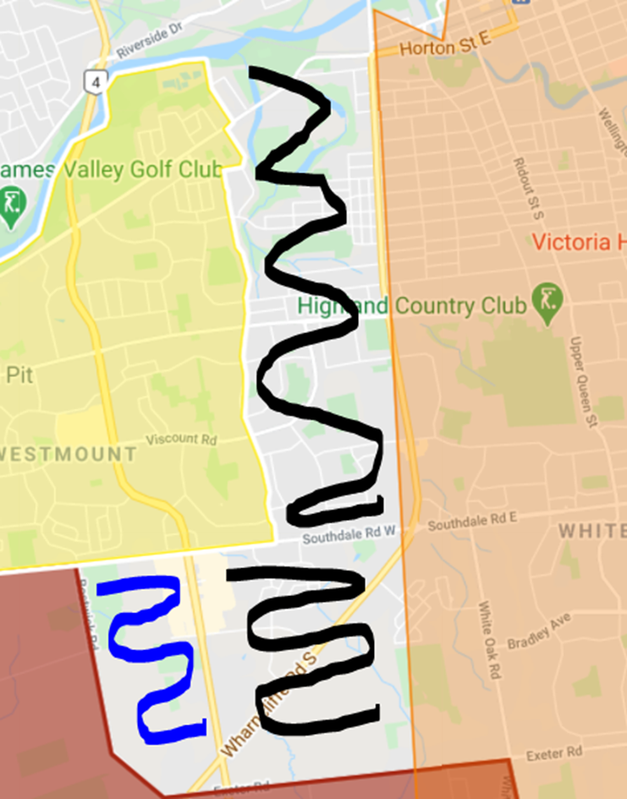
- Jack discussed that he had some issue with some emails and wants to remind everyone that we are all volunteers. We all need to be respected, and I am included in that. Some of the email tonne hasn’t been appropriate.
- Lets not fight with each other, lets work together.
Vice President
CovID Manager | - Tina has followed up with many teams, and we have some issues arising with the possible covid cases, dealing with all these issues, its’ really important that all teams make sure are exporting their covid tracing daily. It’s really hard to go back and trace after the fact. It’s better to have the material ahead of time.  - I have asked Luisa for her help with the app as some teams are experience issues with exporting. It’s been very helpful to have her as she knows how to do some of this stuff.  - All of the information with Covid is confidential and can’t be shared with teams. Quarantine must happen for 2 weeks  - Working together and gathering information.  - Nichols has mapped out great  - Argyle is congested.  - Potential of moving to website app  - Tina has asked to remind parents from peewee and up that you will meet them in the car. Don’t wait for kids in the lobby causes more issues.  - No coffee, no food Jack even reminded everyone. Staff needs to be sanitizing.
Risk Managemnt | - We have some meetings with email protocols, and we have addressed the issues at hand, and we are finishing up some of those meetings.  - Police checks are coming in, and now that we have the new coaches, we will get those addressed.  - Working with Don Drown to set up a database for files for the Risk Management for ongoing passing of information.

Treasurer report: | - Michelle didn’t have her monthly treasurer’s report, there have not been much going on.  - Michelle read the Audit report for the board.  - The Board voted to accept the Auditors report motion to accept Don Drown, Luisa Gould all in favour 21 members in favour.
Secretary/ Webmaster

REGISTRATION |  | Division A/AA Tryout Mustangs MD Tryout MD HL Refunds  IP  Minor Novice  Novice  Minor Atom  Atom  Minor Peewee  Peewee  Minor Bantam  Bantam  Minor Midget  Midget 2002  Midget 2003  Juvenille  Total
ICe Convenor |  | - Not much to report.  - Just need to know which teams lost their ice on the weekend so they can get some returned to them.
VP of Competitive |  | - Not much to report, with the complaints of the city the convenors will be attending the MD ice time to ensure all the rules are being followed.  - Motion to refund a player who wasn’t on the ice because they had a 2 week delay to the start of the season. 44 .00 credit will be applied to their account. Seconded by Gary chenier. Motion was passed with 21 members.  - Parent meetings have occurred.
Vp Of HouseLeague TEAMS | - Pat wants to thank all of her convenors for stepping up and helping out and getting all the coaches settled.  - Passing of all the coaches Motion to pass the coaches listed below Don drown, Graham Babbage.  U9  Jesse Andrews - HC & Covid Manager all passed with 20 in favour  Jessica Harris - HC  Mike Therrien - HC  Chris Richardson - HC & Covid Manager all passed with 20 in favour  Chris Denisovs - AC  U10  Steve Riddell – HC all passed with 20 in favour  Travis Stinchcombe - Trainer  Barb McAllister - Covid Manager  Jeff Gellatly – HC all passed with 20 in favour  Jake Morgan -AC  Fady Faddoul - Trainer  Amy Smith - Manager  U11  Josh Pickering – HC all passed with 20 in favour  Todd Sills - Trainer  Sean Daye - Trainer  Doug Colbourn - HC  Brian McLachlin – Trainer 20 in favour  Travis Clark – Trainer 20 in favour  Jordan Pickering – Trainer 20 in favour  Susan Cordoso - Parent Rep/Covid Manager 20 in favour  U13  Calvin Gould - HC & Covid Manager  Aaron Ford – Trainer 2 abstain and 15 in favour  Darren Gould – AC 2 abstain 15 in favour  Don Pitt – AC 2 abstain 15 in favour  Grant Smith – AC 2 abstain 15 in favour  Morgan Spratt – HC 1 abstain and 16 in favour  Mike Spratt - AC & Trainer 1 abstain and 16 in favour  Aaron Ford – AC 1 abstain and 16 in favour  Pam McNichol - Covid Manager 2 abstain and 15 in favour  U15  Matt Davis - HC & Covid Manager  Kyle Muise – AC 2 abstain 15 in favour  Gary Chenier – Trainer 1 abstain 15 in favour 1 no  Matt Nussey - HC  Don Pitts – AC 1 abstain 16 in favour  Beau Chafee – AC 1 abstain 16 in favour  Chris Duncan – AC 1 abstain 14 in favour and 2 no  Gary Chenier – Trainer 1 abstain 16 in favour  Jennifer Muise – Manager 1 abstain 16 in favour  U16  Mark Lamont - HC & Covid Manager 1 abstain 16 in favour  Gus Kalogero – AC 1 abstain 16 in favour  Shea Hunter – Trainer 1 abstain 16 favour  U18  Randy Pollard - HC & Covid Manager 1 abstain 16 in favour  Chris Duncan - AC & Trainer 1 abstain 16 in favour  Sue Dobbs – Manager 16 in favour  Chris Ferguson - HC & Covid Manager 1 abstain 16 in favour  John Ralf – AC 1 abstain 16 in favour  Ian Colquhoun – Trainer 1 abstain 16 In favour  Sam Popen – Trainer 0 abstain 16 In favour  Motion: to have Coach KM to only attend practices and not the games in order for him to stand for coaching position. Motion was seconded by GChenier, Sara Hunter. Motion was passed with 20 members.  Motion to allow Chris Ferguson to stand for coach for Midget division. Graham seconded this motion and Gary Chenier. Lysney abstain from the vote, Motion was passed with 21 members.  Everything else is running smooth  Shooter tutor has come in handy , even the midgets are using them.

IP Director | - Motion to buy 2 dumbies to help with the skills development of the kids 89.00 a piece Motion was seconded by Graham and Don drown and motion was passed with 21 members.  - Kevin states everything is now up and running well they have 96 kids in total.  - The Javellin app will now be exported and is working well  - Concern about the stickers still being up at the wheel chair base,Jack will email the city .

Player Development | We have started to rotate in other coaches into the Player Development Program, including Jordan Pickering (Josh’s brother) and Jason Hart with the U11-U15 HL group. Shawn Riley helps us out with the U11-U15 HL group. The U7-U9 HL coaches, Kevin Caufield and Scott Habbershaw are out every week and so are Beau Chafee and Inch Rahaman for the U9-U15 MD group. Jeff Bushell has my spot as on-ice helper for the MD group. Thank you to all the coaches for their dedication to our Bandits players.  Jack Boyce ran a coaches clinic on Saturday October 31st between 1:30 and 2:30 pm at Argyle to demonstrate how coaches should conduct their teams outside the arena, how players need to enter the arena and sanitize, players are assigned to a change room, coaches should direct the players to leave the change rooms one at a time, enter through the appropriate door to access the ice pads used at Argyle and Nichols arenas, how to split up the players on the ice, divide the ice along the centre line for station drills and divide the ice up along the middle for flow drills, how to change groups of players during station drills, how to change groups of players to the other end of the ice using the benches, and finally how to remove players from the ice through the appropriate door as designated by the arena. We had 13 coaches turn out for the clinic, the Player and Coach Development convenor and Jack Boyce. A list of participants was sent out to both VP’s Pat and Sue.  A video of the U14 MD Black team, coached by Chris Ferguson, was taken on Saturday, November 7 @ 3pm at Nichols Arena. It captured all of the necessary steps that teams (coaches, players and parents) need to take in order to follow the Covid-19 protocols as requested by the MLHU and the City and London. It demonstrates how to line up outside the arena, shows the covid-19 manager confirmation of player and coach’s wellness on the Javelin app, player entry into the arena, sanitizing upon entry, parents entry and sanitizing upon entry, players and coaches entry onto the ice with the separation of players into groups on the ice, how players navigate station drills and full ice drills on the ice, how players switch sides of the ice using the benches, and how players are to exit the ice as separate groups through the proper exit. Bob McClinchey, a parent on the team, was the videographer and he will edit and narrate the video and produce it for the GLHA this week.  I have spoken with several coaches within the Bandits organization and the consensus is that our coaches would benefit most by having access to drills, videos and chat platforms prepared by IHS, Ice Hockey Systems; https://www.icehockeysystems.com/ . Bandits should consider purchasing a membership as an organization, $575/year for 20 teams and $800/year for 30 teams; this is half price their normal subscription rates! We could ask our coaches if this is of interest to them and then decide what level to purchase. Maybe we can find a sponsor or have teams opt to pay for this.  Subscription will provide the organization with full access to IHS software for every coach. Ability for convenors/directors to recommend drills and practices based upon age levels. Ability for coaches to share practices, drills and systems with their team. Access your drills anywhere! IHS is accessible on desktop, tablet and mobile devices.
Equipment Director | - Jerseys are in and ready for next year  - Gary chenier helping out for the next month but please ensure Craig is emailed as well so he can keep track of everything.  - Motion to refund a player 300.00 towards his registration due to having to purchase his own equipment for goalie. We will get the goalie equipment back and we will credit towards his second half. Motion was seconded by gary chenier and passed with 94 percent.
Tournament Director
Sponsorship Chair | - Jack, asked for support for our Sponsorship chair  - We will address the breakaway program later  - Luisa offered her assistance; a meeting will be held and others offered to support her in this role.

Directors At large | - Gayle purchased the gift for Justice Smith passing

New Business | - Jack is going to leave the committees for this half of hockey and Luisa will send out for the second half. We are having these committees with all your hand picked people and teams. We need to find a way to work together.  - Work on find out what happened to our numbers.
adjournment | MOTION  “That the meeting be adjourned.” (chenier, Drown) at 8:54

